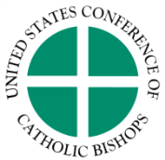Migration and Refugee Services
Office of Resettlement Services
3211 4th Street NE, Washington, D.C. 20017-1194
Tel: (202) 541-3385 ● Fax: (202) 722-8750

Afghan Placement and Assistance Additional Direct Assistance Fund
Expense Report

Affiliates approved for the Afghan Placement and Assistance (APA) Additional Direct Assistance (ADA) funding are required to maintain documentation about the use of dollars, which must be utilized for their intended purpose. You will also need to submit an itemized list of payments to USCCB. All expense reports must be signed by your agency’s Resettlement Director. Email completed document to: ClientEmergencyFunding@usccb.org. Please remember to encrypt the email since client PII is included on this form.

*All funds must be expended first before submitting this expense report for one complete reimbursement.

Catholic Charities Agency:
Resettlement Director:
E-mail
Approved Amount ($)
Expended Amount ($)
SIGNATURE

Itemized List of Expenses:

Category of  Expense | Case Number | Amount ($) | Date of Payment
Rent
Utilities
Connectivity
Other (please describe):

Total Expenditure
Total Budget

