Afghan Food, Groceries, Restaurants

Credits: Sophia Said of Little Rock and her Afghan friends around the US

https://en.wikipedia.org/wiki/Afghan_cuisine

- Meats: Must be halal (do not buy more than 2 pounds of each kind. Once they are settled in they can shop what works best for them)
  - Ground beef preferred
  - Bone-in beef from any part of the cow
  - Chicken (skinless and cut in pieces) preferred
  - Lamb shank if available; its ok if you cannot find it

- Grains & Lentils:
  - White flour/ whole wheat flour – for making naan & noodles
  - Elbow macaroni
  - Maseca yellow corn masa flour or Masa Harina corn flour
  - Masoor dal (red split lentils)
  - Chana dal (split yellow chickpea lentils)
  - Moong dal (split yellow mung beans)
  - Red kidney beans
  - Garbanzo beans

- Rice:
Basmati rice, one 10-pounds. Look for these brands: Aahu barah, Baglani. Mayar, or see the photos below. If you cannot find these, then any white basmati rice will do (but maybe not so much to start)
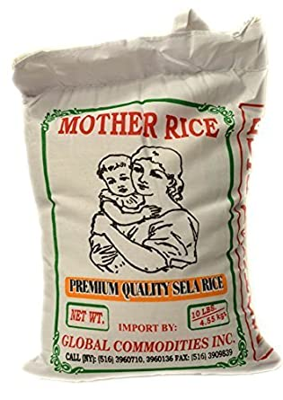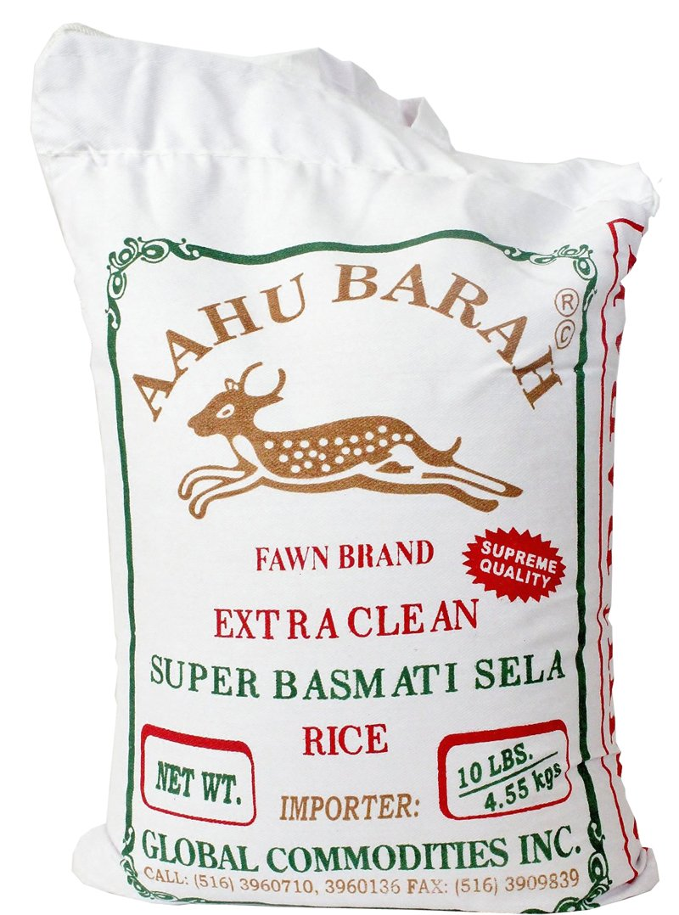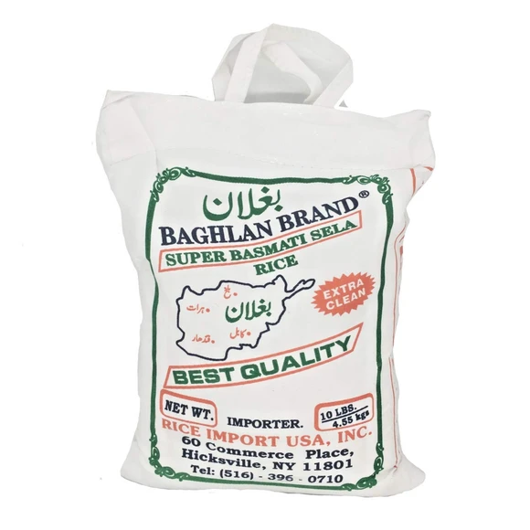

- Dairy:
  - Whole Milk Plain Yogurt (no gelatin). Usually, Afghans prefer to make their own yogurt which they might do eventually but to start with any plain yogurt at Indian grocers is good.
  - Panela cheese
  - The laughing cow cheese
  - Eggs
  - Sour cream (no gelatin)
  - Regular Milk
  - Butter

- Breads:
  - Regular breakfast sliced bread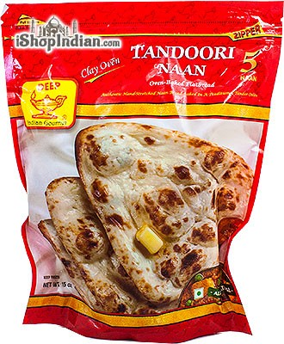
  - Afghan Naan bread is not available in Arkansas grocery stores plus most Afghans make their own bread.
  - Meanwhile this tandoori naan from an Indian store will help for the first week before they start cooking (2-3 packets)

- Fresh Veges:
  - Staple vegetables for every meal: yellow onions, roma tomatoes, potatoes, garlic, ginger, serrano peppers
  - One or two of these vegetables in each grocery trip: eggplant, okra, spinach, turnips, cauliflower, zucchini, squash, bell peppers
  - SALAD: red onions, cucumber, lettuce, cilantro, mint, green onions, carrot

- Fruits:
Afghans love fruit. Any and all of these will do but only buy 2-3 kinds for the first week.
- Apples, oranges, bananas, watermelon, cantaloupe, honeydew, grapes, peaches, pears, mangoes

- Spices & other:
  - Salt, black pepper, sugar, turmeric, cayenne pepper, turmeric, cumin whole and ground both, cinnamon, cardamom, ground coriander, dried mint
  - Noqul (toasted almond)
  - Tomato paste & tomato sauce
  - Oil - canola or vegetable, 1 gallon
  - Any dried fruits or nuts
  - Green tea (Nazo brand preferable or any other brand from Indian store would do)
  - Black loose tea (red label preferred) not tea bags
  - Yeast for making bread
  - Sesame seeds

LOCAL GROCERY STORES for specialty items & halal:

- Zam Zam International Market
9700 North Rodney Parham Rd.
Little Rock, AR 72227
Phone: 501 379 9473

- Indian Market (this is good for spices and grocery but not for meat shopping)
12312 Chenal Pkwy
Little Rock, AR 72211
Phone: 501 916 9277

- Ali Baba
3400 South University Ave.
Little Rock, AR 72204
Phone: 501 379 8011

HALAL RESTAURANTS:

- AL SERAJ MEDITERRANEAN
11400 N Rodney Parham Rd,
Little Rock, AR 72212
Phone: (501) 954-2026

- KABOB HOUSE
11321 W Markham St #4
Little Rock, AR 72211
Phone: 501 246 4597

- TAJ MAHAL
1520 Market St.
Little Rock AR 72211
Phone: 501 520 4900

- ALI BABA
3400 South University Ave.
Little Rock, AR 72204
Phone: 501 379 8011

- Layla’s Gyros
9501 N Rodney Parham Rd #7
Little Rock, AR 72227
Phone: 501 227 7272

