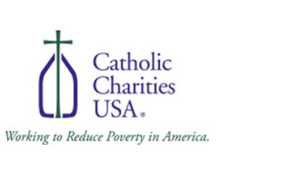

CCUSA Afghan Refugee Response Program for Temporary Housing

Quick Background
What You Need to Know

"For I was hungry and you gave me food, I was thirsty and you gave me drink, a stranger and you welcomed me." (Mt 25:35)

Catholic Charities agencies across the country are assisting in the humanitarian effort to resettle Afghan arrivals. Housing assistance remains a critical issue in refugee resettlement work with limited options for these new arrivals. Catholic Charities USA (CCUSA) will be administering a grant provided by Air BnB for Afghan arrival housing options. The funds are limited, but CCUSA will provide assistance to as many agencies and Afghan arrivals as possible.

Rooted in the Catholic belief that all persons are created in God’s image and are imbued with human dignity that must be recognized and respected, CCUSA is committed to welcoming the stranger. Agencies may complete this Accommodations Request Form and if approved, receive temporary housing assistance for Afghan families being resettled.

How to apply

Included in this document is a simple application form. Please complete the application and submit via email. Application submissions require the signature of the agency Executive Director. Agencies will receive a decision within 10 calendar days of submission. If approved, agencies will have to enter into a sub-grantee agreement with CCUSA and provide program reports and feedback.

Please send any questions and any completed applications to cross@catholiccharitiesusa.org.

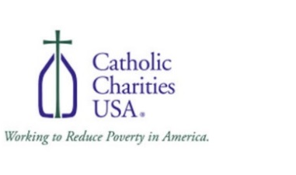

CCUSA Afghan Refugee Response Program for Temporary Housing

SECTION 1: AGENCY INFORMATION
CCUSA Member Agency: _________________YES ______________________NO
(Arch) Diocese Name:
(Arch) Bishop:
Organization Name:
Diocesan Director: |  | Job Title:
Mailing Address: |  | City:
State: | Zip: | Telephone Number:
E-Mail Address:
Programmatic Contact: |  | Job Title:
E-Mail Address: |  | Telephone Number:

SECTION 2: CLIENT INFORMATION
Client Name(s) and Current Immigration Status for each individual:
Total Family Size:
Number of Adults:
Number of Children: |  | Country(s) of origin:
Number of Males: |  | Number of Females:
English Spoken (Y/N): |  | Spoken Language(s):
Accommodation City:
Accommodation State: | Accommodation Zip:
Desired Stay Amount (In Calendar Days): |  | Desired Stay Dates:
If Longer Than 30 Days, please explain why an extended stay is needed:
Special Accommodation Needs (if any): |  | Other Relevant Details (Optional):
Refugee Resettlement Services:

SECTION 3: PARTICIPATION REQUIREMENTS
Please confirm you agree to provide and participate in the following:
- a Sub-grant agreement with CCUSA
- Narrative reports
- Programmatic feedback

TO BE COMPLETED BY CCUSA STAFF
Request Approved: __________________YES ______________________NO
Accommodation Type (Air BnB, Hotel, Motel, Trailer, Vacation Rental, OTHER – please describe):
Accommodation Description:
Accommodation website link (if available):
Approved Length of Stay and Dates:
Accommodation Complete Address:
Accommodation Daily Rate:
Accommodation TOTAL Cost:

- I have read and understand the CCUSA Afghan Refugee Response Program for Temporary Housing Request Form and hereby submit this request for temporary accommodations.

________________________________________________ ____________________
Agency Director Signature Date

